APPERSON SPIRIT WEAR!
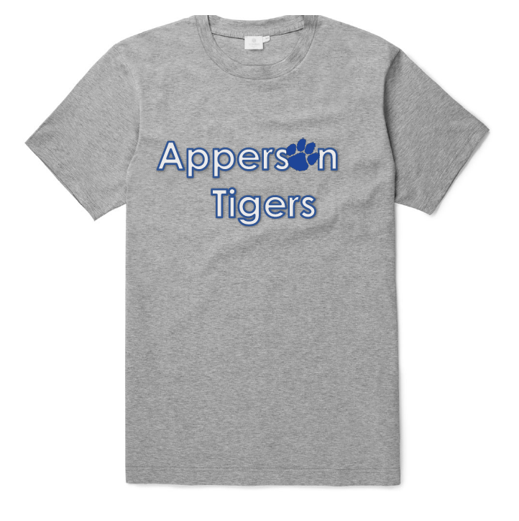

ORDER YOUR APPERSON TIGERS T-SHIRTS TODAY!

All t-shirts are available for immediate purchase! Please fill out form below and return to school with payment. Orders will be filled and returned to classroom.

ONLY $10 each!
All net proceeds go
back to the school.

Name: ____________________________________________________________
Child’s Name: _____________________________________________________
Child’s Room Number: _____________________________________________
Phone Number: ___________________________________________________
Email Address: _____________________________________________________

Please write quantity you would like next to the size:

Youth Sizes: _______YXS _______YS _______YM _______YL

Adult Sizes: _______S _______M _______L _______XL

Total ($10 each): $______________

Mark Payment Type:

_____ Credit Card (we will email you an invoice to pay online) _____ Check _____ Cash
*Please make checks payable to: Apperson PTA
Contact Brooke Battaglia with any questions at brookesbiz@hotmail.com or 818-568-6744
[PTA USE ONLY: Order filled by _______________________ Delivery____________________________]

