APPERSON SPIRIT WEAR!
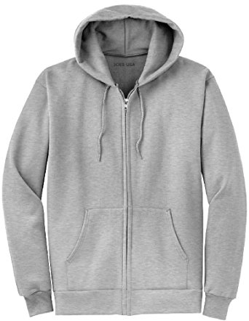

ORDER YOUR APPERSON TIGERS SWEATSHIRTS TODAY!
(No hoodie drawstring on youth sizes)

ONLY $20 each!
All net proceeds go
back to the school.

Most youth and Adult
sizes available!

Name: ____________________________________________________________
Child’s Name: _____________________________________________________
Child’s Room Number: _____________________________________________
Phone Number: ___________________________________________________
Email Address: _____________________________________________________

Please write quantity you would like next to the size:

Youth Sizes: _______YS _______YM _______YL

Adult Sizes: _______S _______M _______L _______XL

Total ($20 each): $____________

Mark Payment Type:

_____ Credit Card (we will email you an invoice to pay online) _____ Check _____ Cash
*Please make checks payable to: Apperson PTA

Contact Brooke Battaglia with any questions at brookesbiz@hotmail.com or 818-568-6744
[PTA USE ONLY: Order filled by _______________________ Delivery____________________________]

